Press release

One system fulfilling all tasks
With SUPERSYSTEM, Zumtobel has created a remarkable LED lighting system that opens up completely new freedom of design to architects and lighting designers: they appreciate the extensive modular system which can be used flexibly across all applications. In autumn 2015, Zumtobel will launch the second generation of the modular lighting tool box which will include SUPERSYSTEM outdoor, thus covering outdoor lighting solutions as well for the first time.
Dornbirn, May 2015 – Zumtobel's innovative SUPERSYSTEM LED lighting system boasts maximum flexibility and, hence, virtually unlimited freedom of design. In addition to its flexibility, the ultra-compatible modular system cannot fail to impress thanks to its minimalist stylistic idiom that ensures the luminaires' unobtrusive appearance in the room. A system for suspension from and fastening to the ceiling is discreetly integrated into an aluminium section. For this purpose, Zumtobel designed the cross-section of the trunking incorporating the entire electronic system as small as possible, so that it is not too dominant in visual terms. With the extended generation, which will be available from autumn, the Austrian lighting solution expert has supplemented its SUPERSYSTEM range by numerous functions, making use of cutting-edge LED technology and advanced lighting technology. Replaceable lenses ensure convenient and easy adjustment of the system to changed conditions. Three spotlight sizes with a diameter of 25, 45 and 65 mm available in the housing colours white, black and silver, lenses developed for various lighting concepts and a variety of high-precision tools such as a Vario lens, glare control tools, honeycomb mesh, barn doors and wallwashers are added to the existing portfolio.
With the new products added to the product range, it is now for the first time possible to use Zumtobel's SUPERSYSTEM in outdoor applications. SUPERSYSTEM outdoor is similar to the versatile lighting system for indoor applications and allows targeted illumination and presentation of outdoor spaces. The solution for outdoor spaces provides accents for vertical as well as horizontal surfaces and ensures a harmonious appearance of buildings both at daylight and by night. Squares and footpaths can be uniformly lit and flexibly integrated into urban surroundings. The product range's high variability allows to develop customer-specific lighting designs for indoor and outdoor applications using one single system.
Due to its nearly unlimited number of possible combinations, the solution is above all suitable for highly sophisticated lighting concepts. Until now, the system has primarily been applied in the areas of Art & Culture, Hotel & Wellness as well as Shop & Retail. Thanks to the additional products, SUPERSYSTEM has now also become an interesting option for implementing sophisticated lighting concepts in residential areas.
SUPERSYSTEM facts & figures
- High-precision accent lighting with a power consumption of either 4 W, 10 W or 15 W
- Three spotlight sizes with a diameter of 25, 45 or 65 mm
- Lenses, reflectors and filters designed for a variety of lighting concepts
- Wallwashers, batten luminaire
- Housing colours: white, black and silver
- For indoor and outdoor use
- LED spots rotate through 360° and pivot through 90°
- Choice of colour temperatures: warm (3000 K) and intermediate (4000 K) white
- Excellent colour rendering of Ra > 90
- Service life: 50,000 hours
- Extensive range of accessories: anti-glare tube, ring louvre, honeycomb mesh, picture framing, barn doors

Captions:
(Photo credits: Zumtobel)

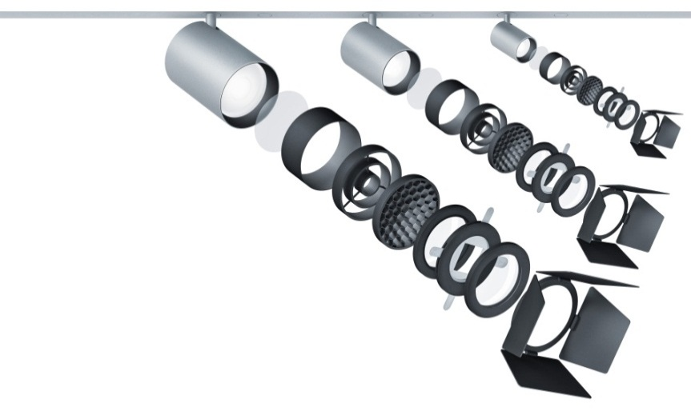
Fig. 1: With the latest generation of SUPERSYSTEM, Zumtobel adds versatile lighting tools to this product range.
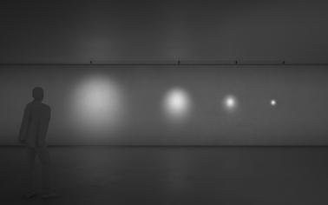
Fig. 2: Visualization Zumtobel SUPERSYSTEM 40, 24, 16 und 8 degrees reflector.
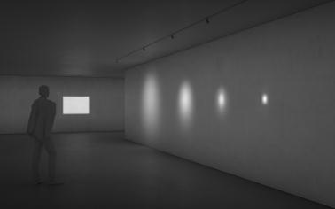
Fig. 3: Visualization picture framing SUPERSYSTEM and 40, 24, 16 and 8 degrees reflector.
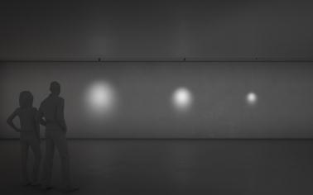
Fig. 4: Visualization Zumtobel SUPERSYSTEM spot size 65 mm, 45 mm, 25 mm frontal.
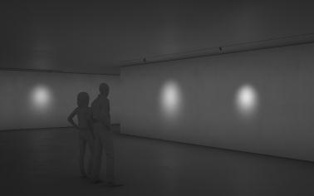
Fig. 5: Visualization SUPERSYSTEM spot size 65 mm, 65 mm, 45 mm, 25 mm recessed surface mounted.
Press contact:
Zumtobel Lighting GmbH
Sophie Moser
PR Manager
Schweizer Strasse 30
A-6850 Dornbirn

Tel +43-5572-390-26527
Mobil +43-664-80892-3074
E-Mail press@zumtobel.com
www.zumtobel.com

Sales contact:
Zumtobel Lighting Ltd.  Chiltern Park  Chiltern Hill, Chalfont St Peter  Buckinghamshire SL9 9FG  United Kingdom  Tel: +44 1753 482 650  Fax: +44 1753 480 350  uksales@zumtobel.com  www.zumtobel.co.uk | Zumtobel Lighting Inc.  3300 Route 9  Highland , NY 12528  United States  Tel: +1 845 691-6262  Fax: +1 845 691-6289  zli.us@zumtobelgroup.com  www.zumtobel.us

For further contact details in further sales regions please visit: http://www.zumtobel.com/com-en/contact.html

About Zumtobel
Zumtobel, a leading international supplier of integral lighting solutions, enables people to experience the interplay of light and architecture. As a leader in innovation, Zumtobel provides a comprehensive range of high-quality luminaires and lighting management systems for professional interior lighting in the areas of offices, education, presentation & retail, hotel & wellness, health, art & culture as well as industry. Zumtobel is a brand of Zumtobel AG with its head office in Dornbirn, Vorarlberg (Austria).
Zumtobel. The Light.

